This is subpage:

Application error: a server-side exception has occurred while loading aussieduo-two.vercel.app (see the server logs for more information).
Digest: 3772608234

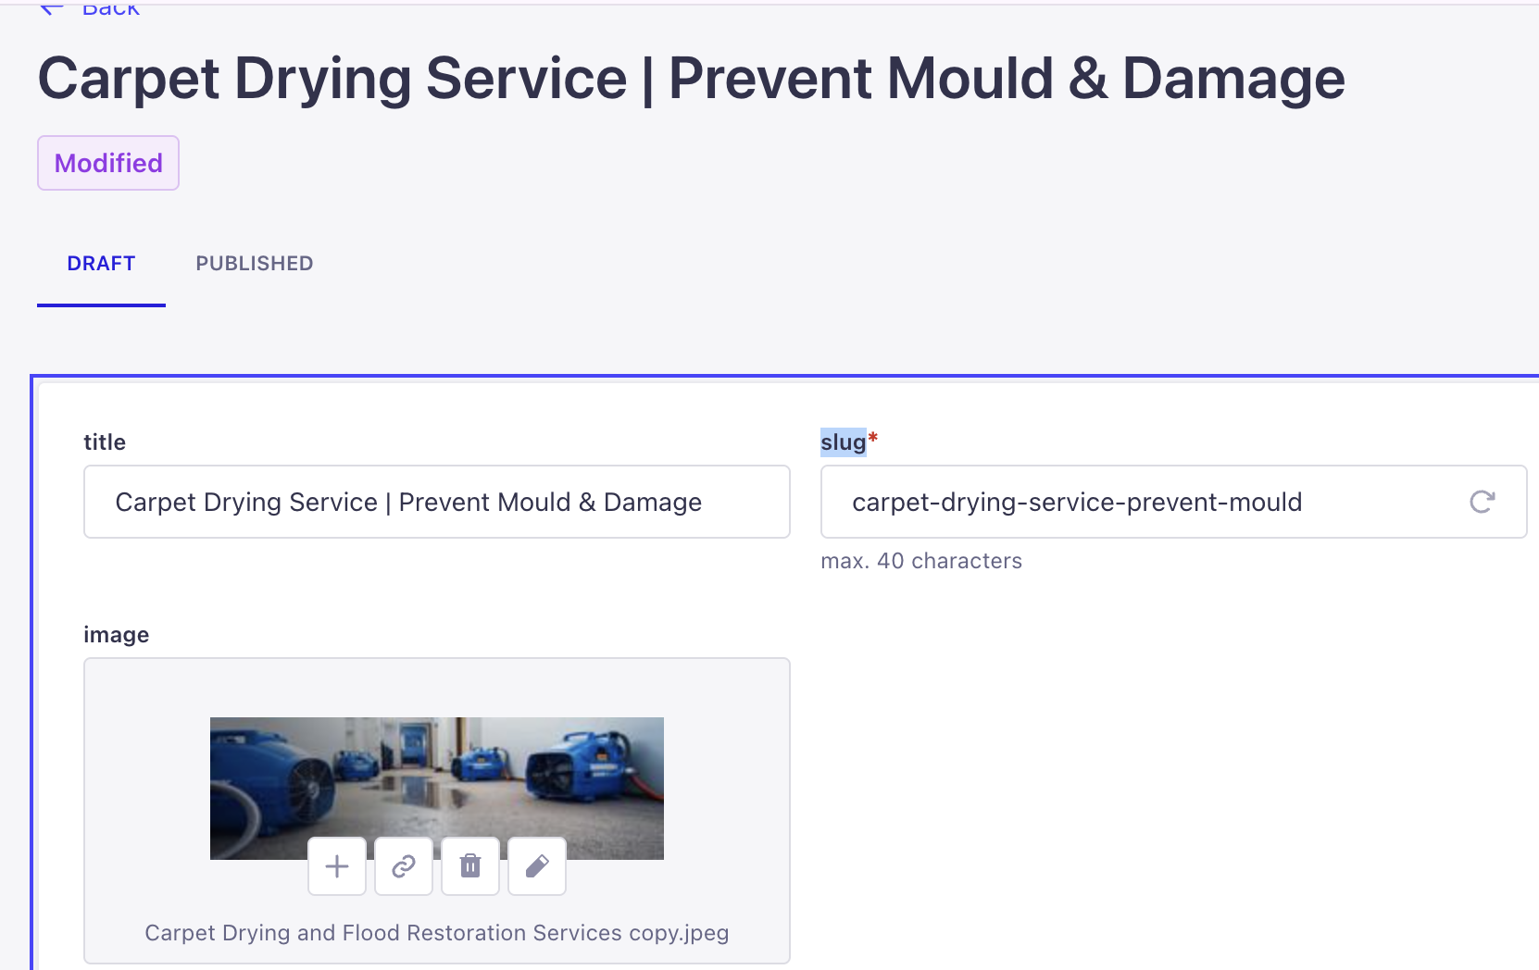

Issue: Changing the “slug” field in Strapi does not change the frontend URL.
Question: Are we using code-driven routes or slug-driven routes?
- Are service URLs like /services/carpet-drying hard-coded in Next.js or generated from a Strapi slug field?
- If slug-driven is intended:
  - Is there a dynamic route like /services/[serviceSlug]?
  - Does getStaticPaths / generateStaticParams use service.slug from Strapi?
  - Does getStaticProps / loader fetch the service by slug?
  - Is revalidation / webhook configured so the page regenerates when I change the slug?
- If we are keeping the code-only routing (as per earlier architecture), please confirm:
  - Which file defines the /services/carpet-drying route?
  - How do we change that path and add a 301 redirect if we rename it?

Homepage:
should pull services/blogs dynamically from Strapi (title, excerpt, image, slug), not be hard-coded. Right now when I create a new entry in the backend it doesn’t show. Please wire the homepage to the Strapi collections and enable revalidation/webhook so content changes appear without redeploy.”

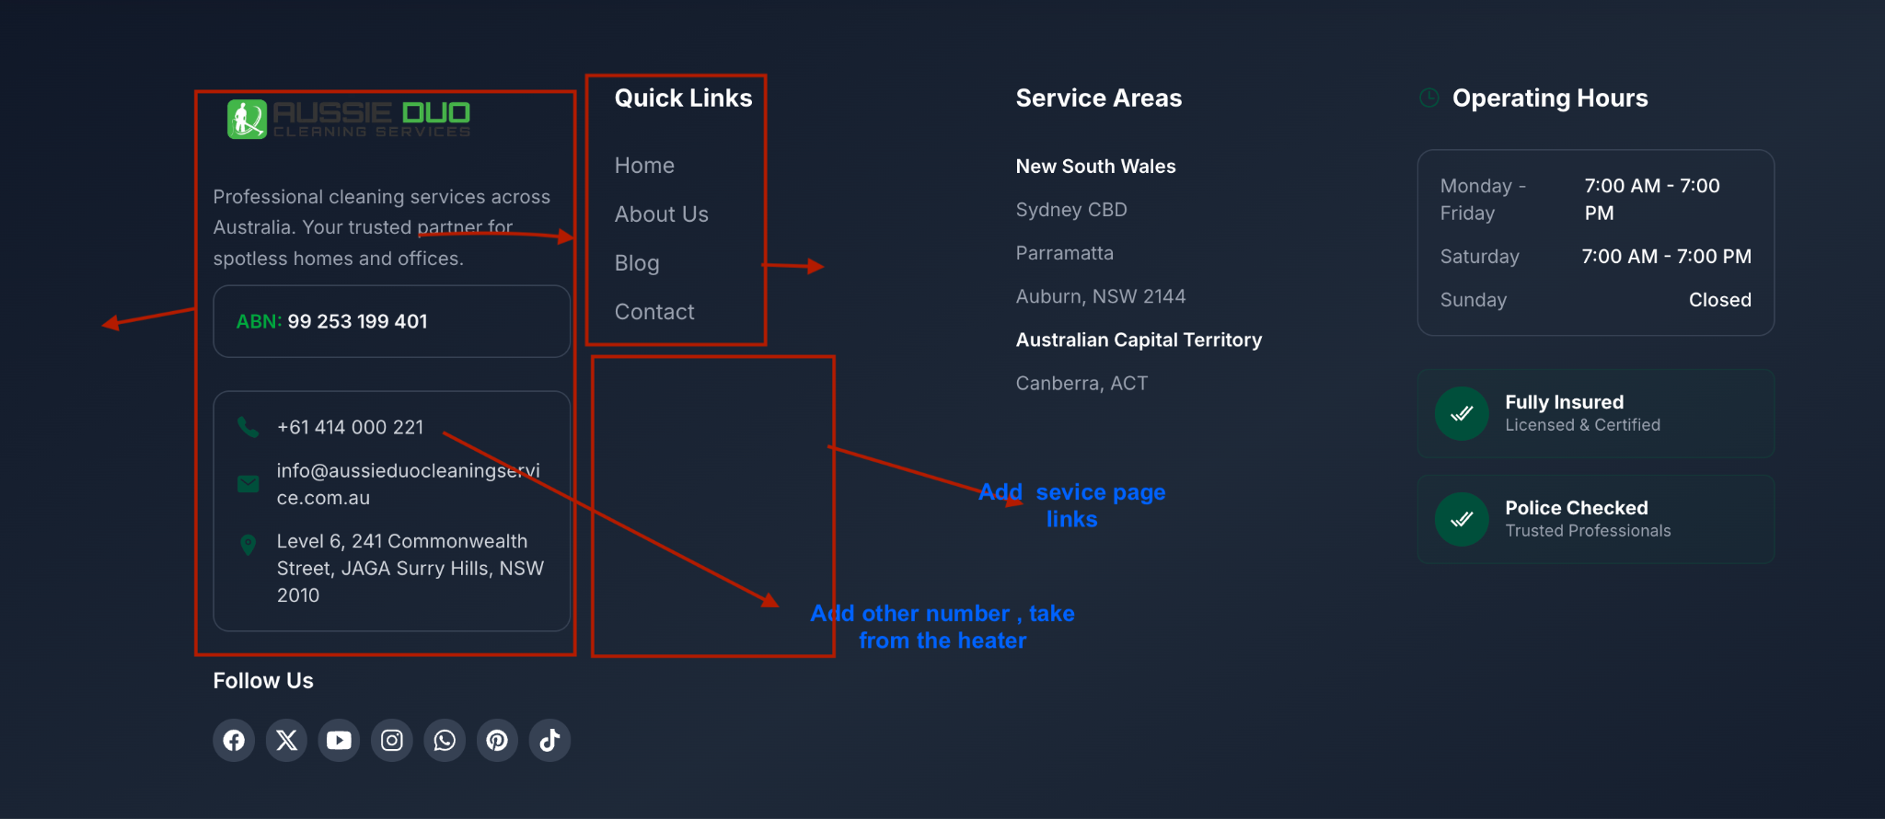

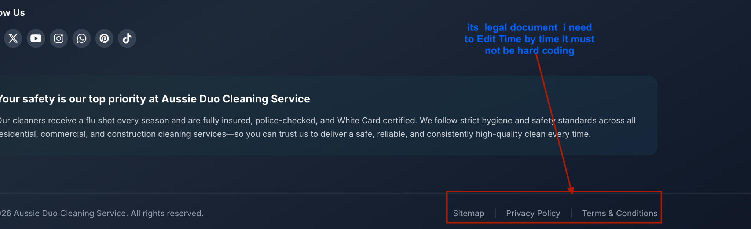

There is no table that i can add from the blog post: or the page. If the do have the you need to show me if not you need implement,

In the blog post how do link the “wordpress and PDF files make the visitors to download ?

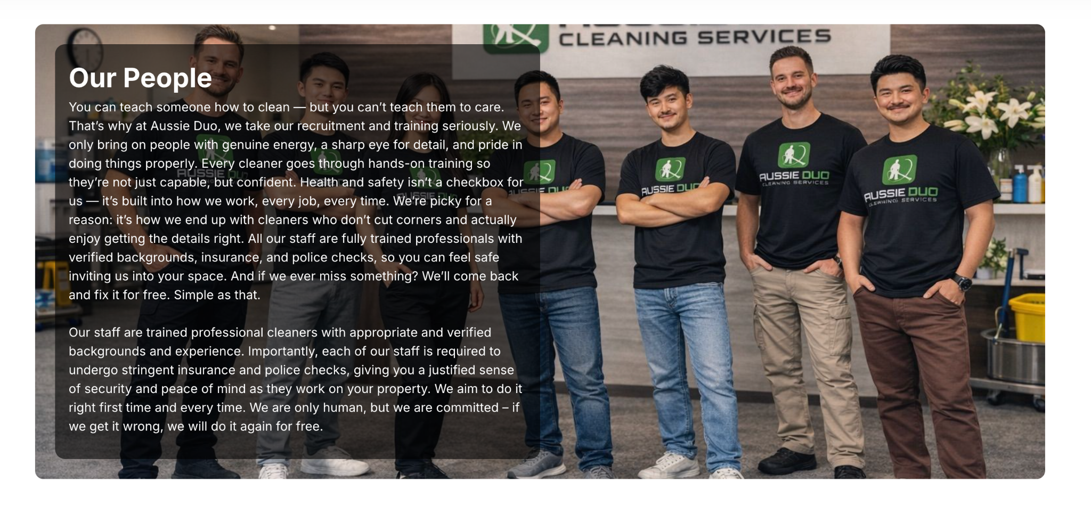

The photo must be Visible without blocking so important picture and content separately and all the service pages and home page currently Can’t create paragraph like “enter “ this so bad on the mobile too

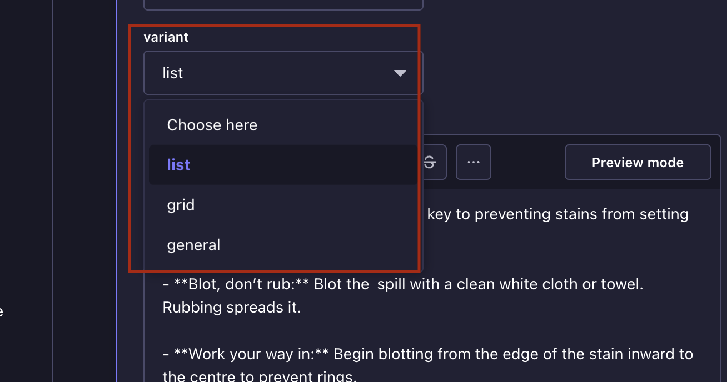
Those are not working

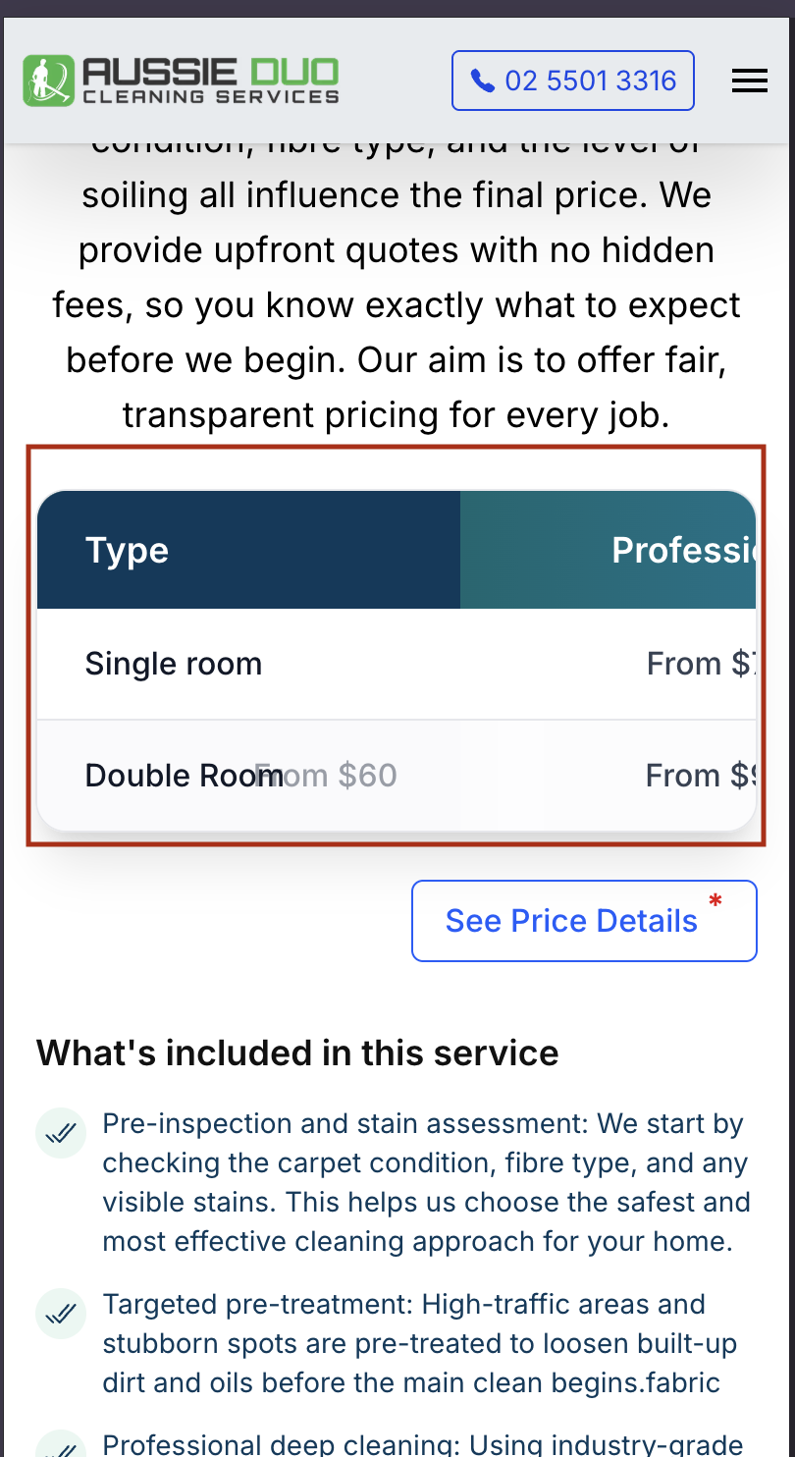

See the Element of the content and the price section everywhere is messy on the mobile phone

